DCF255 Assignment 1   
  
**Introduction:**

This Assignment is an individual task and worth 5% of the total assignment grade (15%). Answer the following questions and support your answer with diagrams as per your answer and submit it on the link provided on MySeneca under DCF255.

1. A ‘Travision Trips’ is an e-travel portal to help travelers/tourist a complete travel solution. The company’s vision is to provides its customers a platform where they can plan their vacation themselves. It provides its customers a to craft their vacations as per their budget and choices. Their services includes lodging, transportation (that includes car rental services, bus trips, rail, air) and leisure activities. To get the users must logged in with their account and once users are logged in, they provide their choices as well as the budget. The application gives suggest the possible solutions as per choices provided by the user. To provide these services ‘Travision Trips’ has developed an E-commerce solution ‘Travision Easy Access’, that provide users an access to all the services via their software. ‘Travision Easy Access’ have direct accesses to the databases of all the service providers whose services can be accessed via “Travision Trips’ web portal. Your task is to draw and labeled an n-tier architecture of ‘Travision Trips’. [5Marks]

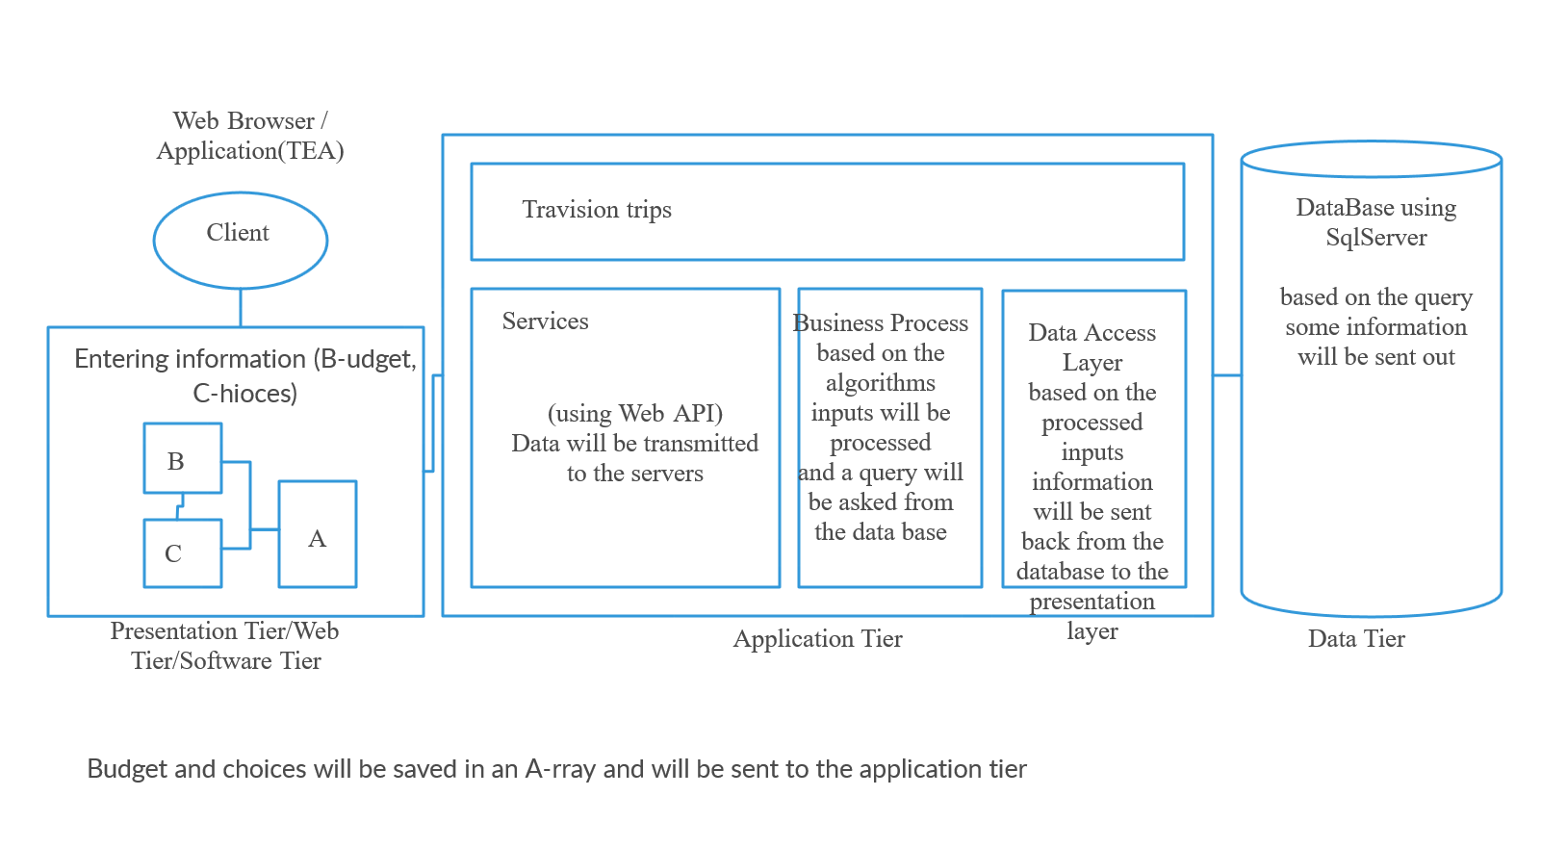

1. Structure the airline travel system by supposing that you travel from Toronto to London by air.
   1. Identify and discuss the series of actions you take in a five layered architecture from the start of your journey at Toronto and then five layered actions at the arrival on destination London. [5 Marks]
   2. Support your answer by drawing a layered architecture at the starting point of the journey and the destination. Your answer must identify and discuss the action identified both at Toronto and London. [5 Marks]

Application(airport): I will check-in in the airport of source(Toronto) and they will tell me which gate should I go

Transport(gate): (airline-employees) they check my passport my ticket and my visa, they get, check my luggage and put stickers on it and will give me information that which boarding section should I go

Internet(boarding-section): (airport-employees) they check my boarding section, put quit stamp on my passport and I have to wait until the boarding time

Data-link(boarding time): (flight attendant) they will check my ticket and punch it if it matches their flight information and will direct me to my reserved sit

Physical: I go in and sit on my reserved place and will wait until I arrive

-physical: I am arrived and will quit the plane

-data-link(checking if everything is fine): (flight attendant) they will tell me we have arrived without any problem and will show me where should I go ( to get entering stamp and check in to the country)

--internet(Disembark-section): they final check my passport, visa and other information, will put entering stamp on it and will route me to pick up my luggage

--transport(luggage-pickup): I pick up my luggage and will go out of the airport

--application(London): I enter to London

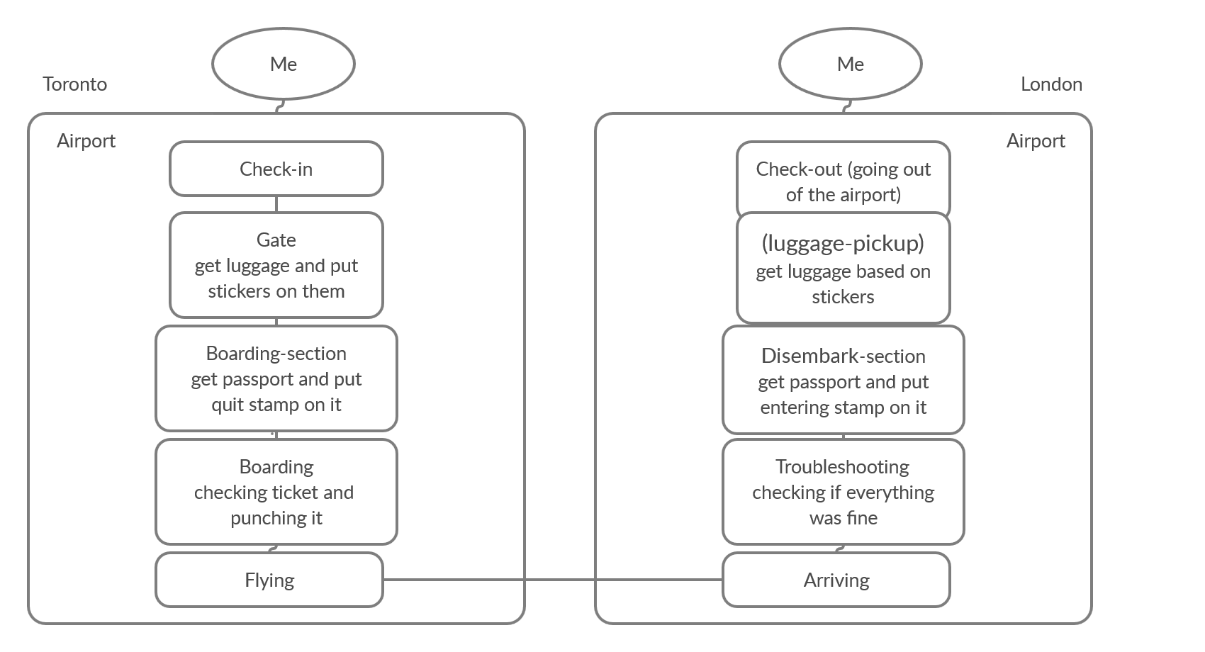

1. Assume that you are accessing a Seneca website from your home computer (desktop/laptop/tablet).
   1. Identify and discuss the method used at your home to access the Internet and then connection with the Seneca web server. [5 Marks]
   2. Sketch/draw a network connection from your device to the Seneca web server. [5 Marks]

Basically there are a lot of ways which I can access Seneca web server but for example assuming that im sitting in my bedroom using my laptop and connected to our wifi the process is that

I enter the url on my browser >> by pressing enter the http requesting process will be transmitted to the layers and be handed to the wifi router at my home >> it will check for possible errors will be sent by bridge connection >> my request will get a public address and will be sent to the router >> it now will be sent to the Seneca servers >> from there their routers will get the easiest and fastest route to their database >> and will go back all the way to get the data to my browser.

